UHF Reader Demo Guidance

Table of contents

1 Introduction 3
2 Reader Parameter Settings 3
2.1 Connected To A Serial Port 3
2.2 Connected To Net Port 5
2.2.1 Setting Host IP 5
2.2.2 Setting Reader Parameter 6
2.2.3 Software connect 7
2.3 Out Power Setting 8
2.3.1 Set Power Parameter 8
2.3.2 Read Power Parameter 8
2.4 Reader Frequency 9
2.4.1 Set Frequency 9
2.4.2 Get Frequency 9
2.5 Read And Write Tag 9
2.5.1 Read Tag 9
2.5.2 Write Tag 11
2.5.3 Write /Read EPC 11

1 Introduction
The Reader Program is purposed for the reader listed below:
The involved technology is ISO18000-6C .
The program is designed for Microsoft Window environment and supporting the WIN95
,WIN98,WIN me WINXP,WIN7 and WIN8.

2 Reader Parameter Settings

2.1 Connected To A Serial Port
Open the UHF Demo, Effect as shown in Figure 2.1 A .

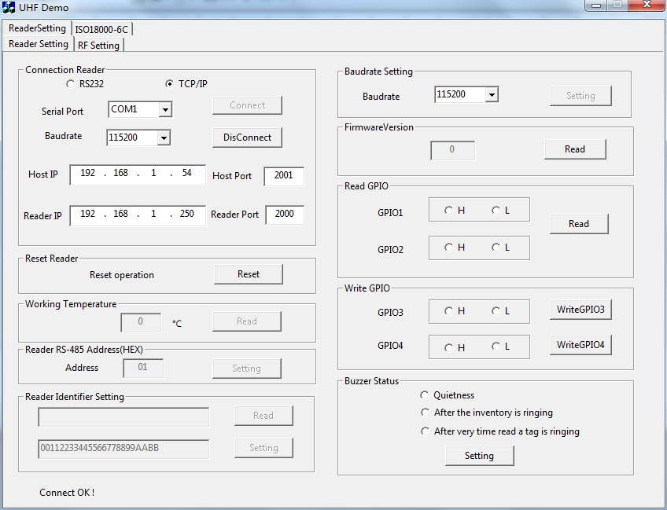

Figure 2.1 A

Connect Serial Port :Selection parameter and click the button of “Connect”.
Port: COM1/COM2/COM3/COM4,according to the computer serial number to decide
Baud: 115200 bps
Effect as shown in Figure 2.1 B。

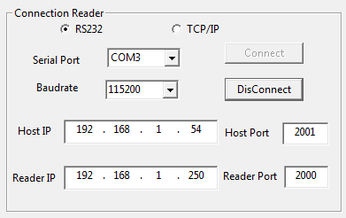
Figure 2.1 B

Figure 2.1 C

2.2 Connected To Net Port
TCP/IP : Network communication connection.
Effect as shown in Figure 2.1 C.

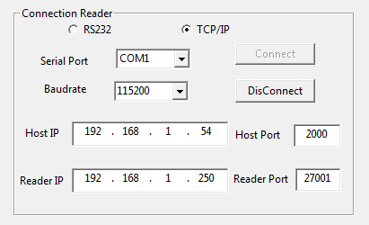

Host IP: 192.168.1.*** Host Port:2000
Reader IP: 192.168.1.250 Reader Port 27001

2.2.1 Setting computer IP
Computer IP as follow

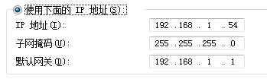

Load in reader setting UI
Usually , Default IP is 192.168.0.250 , testing IP is 192.168.1.250

2.2.2 Setting Reader

Step：

Put in：192.168.1.250



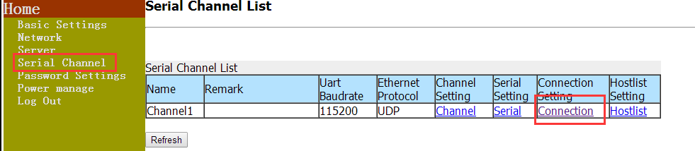

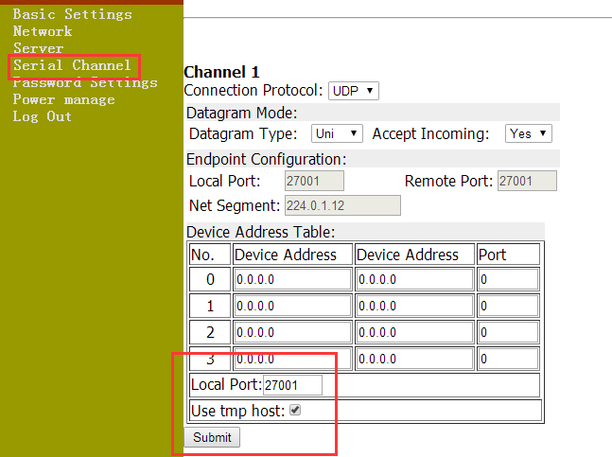

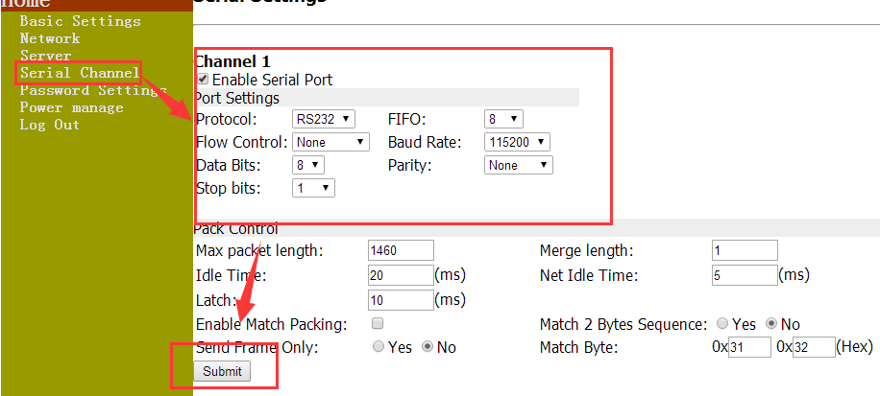

2.2.3 Connect to reader

Put Host/Reader IP and Host/ Reader Port as below , then Connect
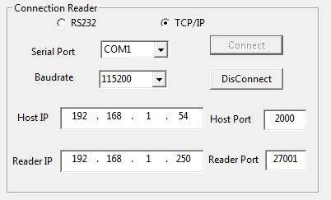

2.3 Out Power Setting

2.3.1 Set Power Parameter
Input power parameter,Click the button of “Setting”,Effect as shown in Figure 2.2.1A and Figure 2.2.1 B.

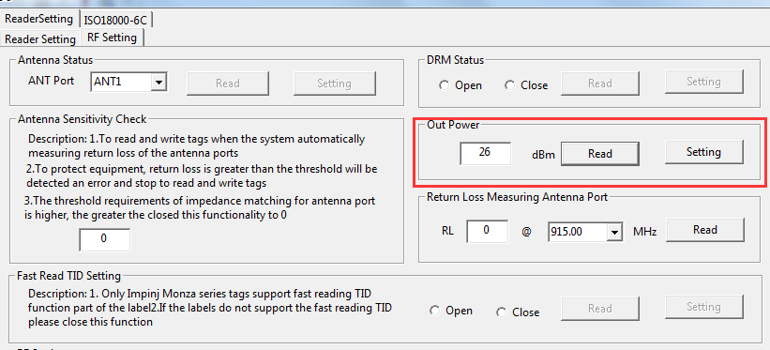

Figure 2.2.1 A

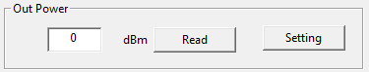
Figure 2.2.1 B

2.3.2 Read Power Parameter
Click the button of “Read”,Effect as shown in Figure 2.2.2.

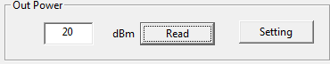
Figure 2.3.2

2.4 Reader Frequency

2.4.1 Set Frequency
Input requency parameter,Click the button of “Setting”,Effect as shown in Figure 2.4.1.

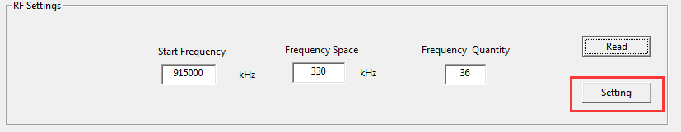

2.4.2 Get Frequency
Click the button of “Read”,Effect as shown in Figure 2.4.2.

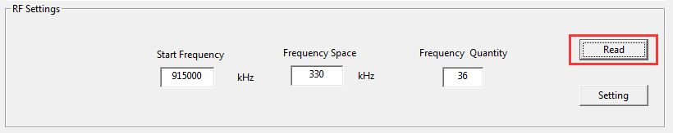

Figure 2.4.2

2.5 Read And Write Tag

2.5.1 Read Tag

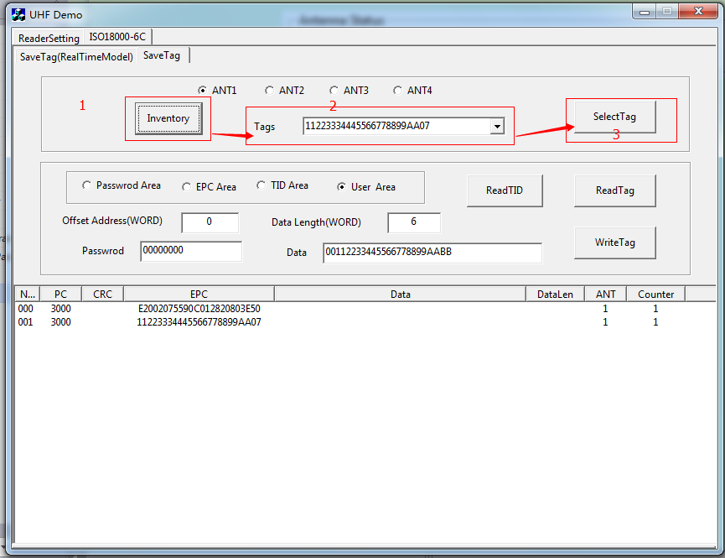
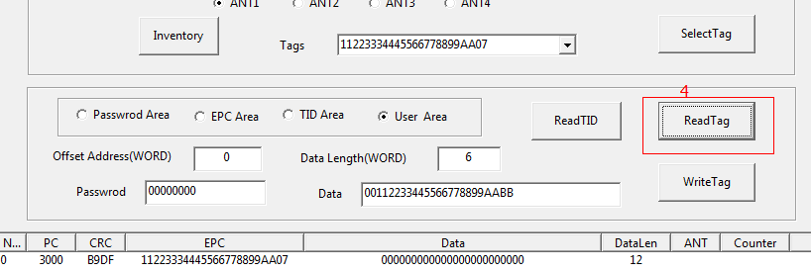

2.5.2 Write Tag

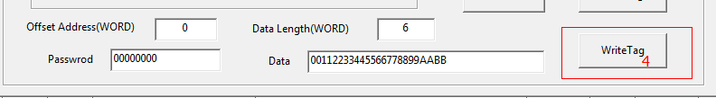

2.5.3 Writing /reading EPC

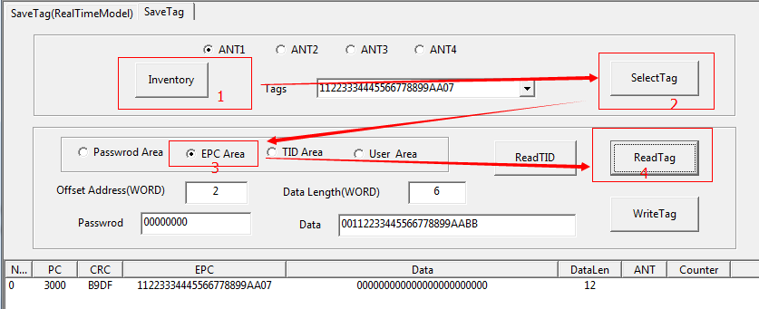

Then

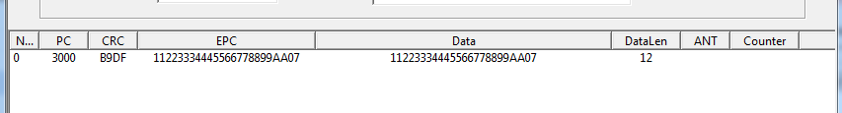

Tip：1word =2 byte 12byte=6 word

EPC ID description：

Address | 0-1 | 2-4 | 5-15
Description | Check Digit | PC | EPC ID

If PC=0x30 00, means EPC length is 12bytes (6 words)
If PC=0x20 00 ,means EPC length 8bytes (4 words)
If PC=0x10 00 ,means EPC length 4bytes (2 words)

For example:
Change EPC 11223334445566778899AA07 (12 Bytes) to 44332211 (4 Bytes)
“Data” put into：100044332211 （PC Value+ EPC data）offset address=1,data length =3word(6bytes)

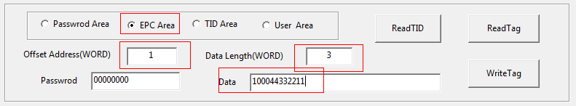
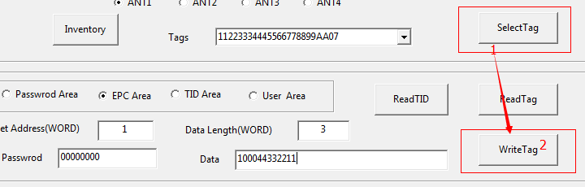
Then, reading the tag, turn out as below

